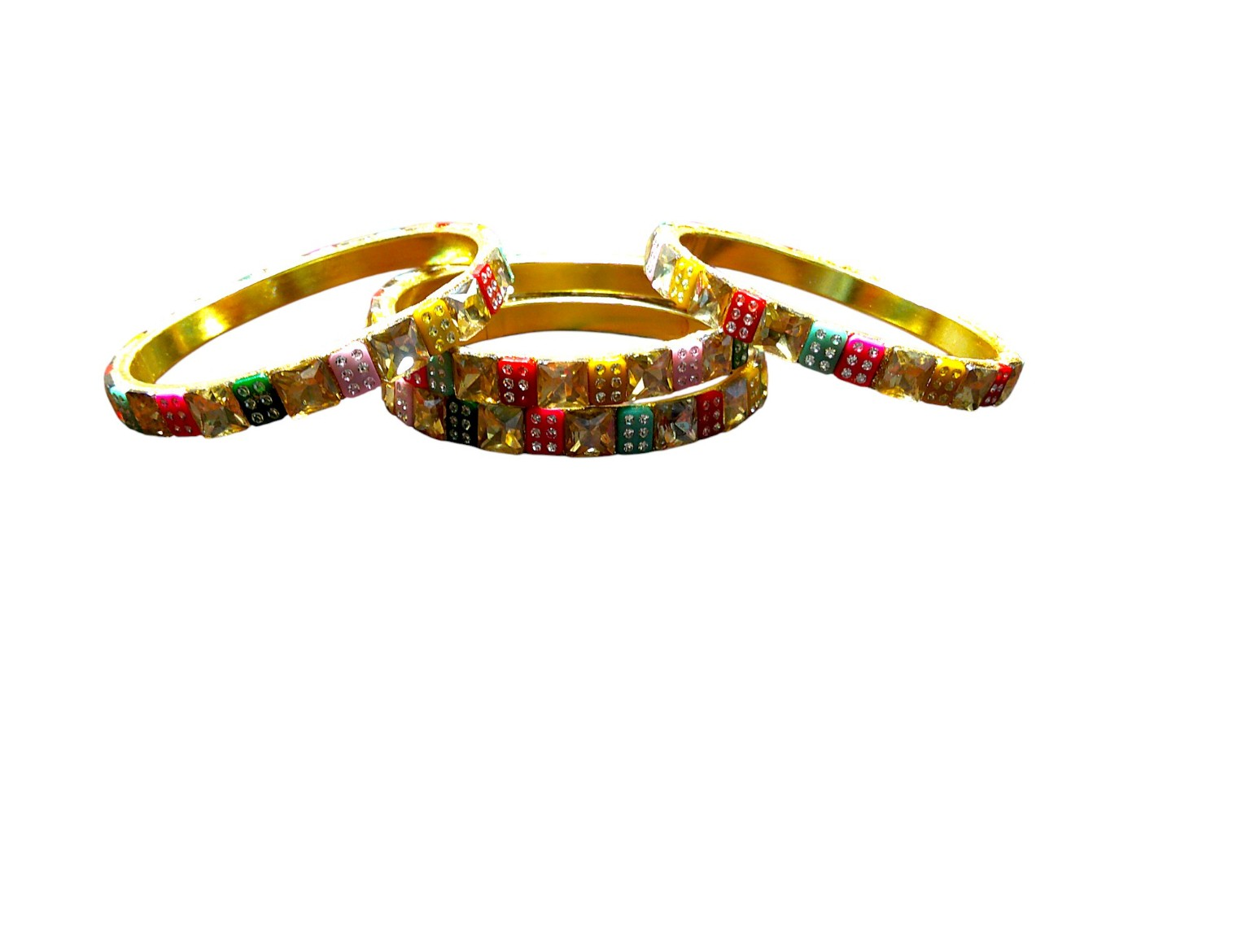

Nari Nakhre Multicolour Jaipuri Brass Kada Set of 4

Product Description
Description for Amazon, Flipkart, and Meesho:
Introducing the Multicolour Jaipuri Brass Kada Set of 4 by Nari Nakhre, a brand by Mohini Cosmetics. Crafted in Jaipur, Rajasthan, this set of 4 designer Kadas or bangles showcases a traditional ethnic design with vibrant multicolour patterns. Made of premium Brass, these Kadas are perfect for daily wear, festive occasions, or weddings, combining tradition with modern elegance.
Description for Shopify:
Introducing the Multicolour Jaipuri Brass Kada Set of 4 by Nari Nakhre, a brand by Mohini Cosmetics. Crafted in Jaipur, Rajasthan, this set of 4 designer Kadas or bangles showcases a traditional ethnic design with vibrant multicolour patterns. Made of premium Brass, these Kadas are perfect for daily wear, festive occasions, or weddings, combining tradition with modern elegance. For further details, please visit www.narinakhre.com or mail at hello@mohinicosmetics.com.

Key Features
• Set of 4 multicolour designer Kadas with stone and enamel work
• Crafted with high-quality Brass for durability and elegance
• Traditional Jaipuri design from Rajasthan
• Perfect for festive, wedding, and daily wear
• Comfortable fit for women and girls

Product Details
Product Title: Nari Nakhre Multicolour Jaipuri Brass Kada Set of 4
Colour: Multicolour with Gold-tone base
Model Name: NNJaipuriBrassKada024
SKU ID: 052025KAD24021
Model Number: NNKADA024021
Product Type: KAD
Search Keywords: Multicolour Kada, Brass Bangles, Jaipuri Jewelry, Designer Kada, Traditional Bangles, Ethnic Kada
HSN Code: 71171910
GST Rate: 3%
MRP: ₹899
Selling Price: ₹349
Manufacturer and Importer: Mohini Cosmetics, 136 Darhai Rd, Kotwali, Jabalpur, Madhya Pradesh, 482001, India, hello@mohinicosmetics.com

